MINI PROJECT: MECHATRONICS SYSTEM INTEGRATION
TITLE
SMART WASHING MACHINE
AUTHORS
Muhammad Syazani Akmal Bin Mohd Nasarudin, Muhammad Iman Farihin bin Mohd Imran, Ainin Sofiya binti kamaruzaman,

Department of Mechatronics Engineering, International Islamic University Malaysia

ABSTRACT
This paper details the development of a Smart Washing Machine prototype that integrates manual and IoT-based control systems to enhance user convenience and operational safety. The system employs a Master-Slave architecture: an Arduino Mega 2560 functions as the Master controller, managing the Human-Machine Interface (HMI) via an LCD, buttons, and potentiometer, while an ESP32 serves as the Slave controller, handling high-power actuation (DC Motor, Servo Lock), sensor data acquisition (Ultrasonic, Accelerometer), and cloud connectivity via the Blynk IoT platform. Experimental results validate the system's "fail-safe" logic, where motor operation is strictly conditional on door closure (measured by ultrasonic distance < 15cm) and vibration stability (acceleration < 15.0 G). The prototype successfully demonstrates real-time synchronization between physical inputs and the mobile app.
1. INTRODUCTION
Household washing machines commonly encounter challenges related to mechanical stability, operational safety, and limited user feedback. Conventional systems typically lack advanced diagnostic capabilities for detecting unbalanced loads during operation, which can result in excessive vibration, noise, and long-term mechanical damage. User interaction is often restricted to predefined presets with minimal real-time status information, reducing user awareness and control. As domestic appliances continue to evolve toward smarter and more connected systems, there is an increasing demand for washing machines that integrate safety monitoring, intuitive user interfaces, and remote accessibility (Al-Fuqaha et al., 2015; Gubbi et al., 2013).
Previous studies have demonstrated that inertial measurement units (IMUs), such as the MPU6050, are effective in identifying abnormal motion and vibration patterns in rotating machinery, thereby improving operational safety (Lee, 2015). Improvements in appliance usability and ergonomics have also been observed when visual interfaces, such as liquid crystal displays (LCDs), are combined with tactile input devices including potentiometers and push buttons (Bolton, 2021). Real-world incidents, such as washing machines shifting position due to load imbalance or water overflow caused by sensor malfunction, further highlight the necessity for an integrated sensing and feedback approach that extends beyond basic electromechanical control.
In response to these limitations, this project aims to design and implement a smart washing machine control system that enhances safety, usability, and system awareness. The proposed system focuses on monitoring mechanical stability using an IMU, regulating water levels through sensor-based feedback, and enabling flexible wash mode selection via intuitive user inputs. An ESP32 microcontroller serves as the central processing unit, handling real-time sensor data acquisition and system control while supporting wireless communication for remote monitoring and control through a smartphone application (Rajput & Pandey, 2019).
This work contributes a modular smart washing machine control architecture that integrates real-time mechanical stability assessment, and adaptive user interaction within a unified embedded framework. Unlike conventional washing machine controllers that rely on isolated sensing mechanisms and static control logic, the proposed system employs coordinated multi-sensor data acquisition combined with both local and IoT-enabled feedback pathways. The implementation demonstrates how distributed embedded control, supported by wireless connectivity, can enhance operational safety, fault awareness, and system responsiveness while remaining suitable for low-cost domestic appliance applications.

Table 1: Table of comparison
Ref/year | Project name | Advantages | Disadvantages | Comparison to my proposal
[1]/2020 | Automatic Washer Controller | Robust motor control using PLC | No remote monitoring or stability alerts | My project replaces PLC with a single ESP32 for wireless connectivity and stability monitoring.
[2]/2021 | IoT Washing Monitor | Basic Wi-Fi notifications for cycle end | Lacks physical UI for mode selection | My project includes a potentiometer and LCD for local mode selection alongside IoT features.
[3]/2022 | Vibration Detection System | High accuracy in detecting mechanical faults | No water level management or user control | My project combines motion sensing with water level sensors and a full user control interface in one system.
[4]/2023 | Water-Saving Smart Machine | Precision water level control | Lacks local status indicators (LEDs/Buzzers) | My project adds buzzers and LEDs to provide immediate audio-visual feedback to the user.
2. METHODOLOGY
2.1 Project Development
The Smart Washing Machine system is designed as a distributed mechatronic unit, utilizing a Master-Slave architecture where an Arduino Mega 2560 manages the user interface and an ESP32 handles hardware actuation and IoT connectivity. The project development focuses on the integration of three core functional areas: Safety Monitoring, User Interface, and Automated Actuation.
The ESP32 subsystem integrates the MPU6050 motion sensor, which continuously tracks the machine's stability during the spin cycle. If the machine becomes unstable or tilted, the ESP32 is programmed to automatically cut power to the DC motor and trigger an alert.
For user interaction, the Arduino Mega utilizes a potentiometer to allow the user to navigate through different wash modes, which are displayed in real-time on an LCD. Two push buttons connected to the Mega provide dedicated 'Start' and 'Stop' functions. Status indication is handled by three LEDs (Ready, Running, and Stopped), while a buzzer provides audible signals at the start and completion of the cycle. This dual-controller architecture ensures efficient task distribution, allowing the Mega to handle responsive display updates while the ESP32 dedicates resources to high-speed motor control and sensor processing.

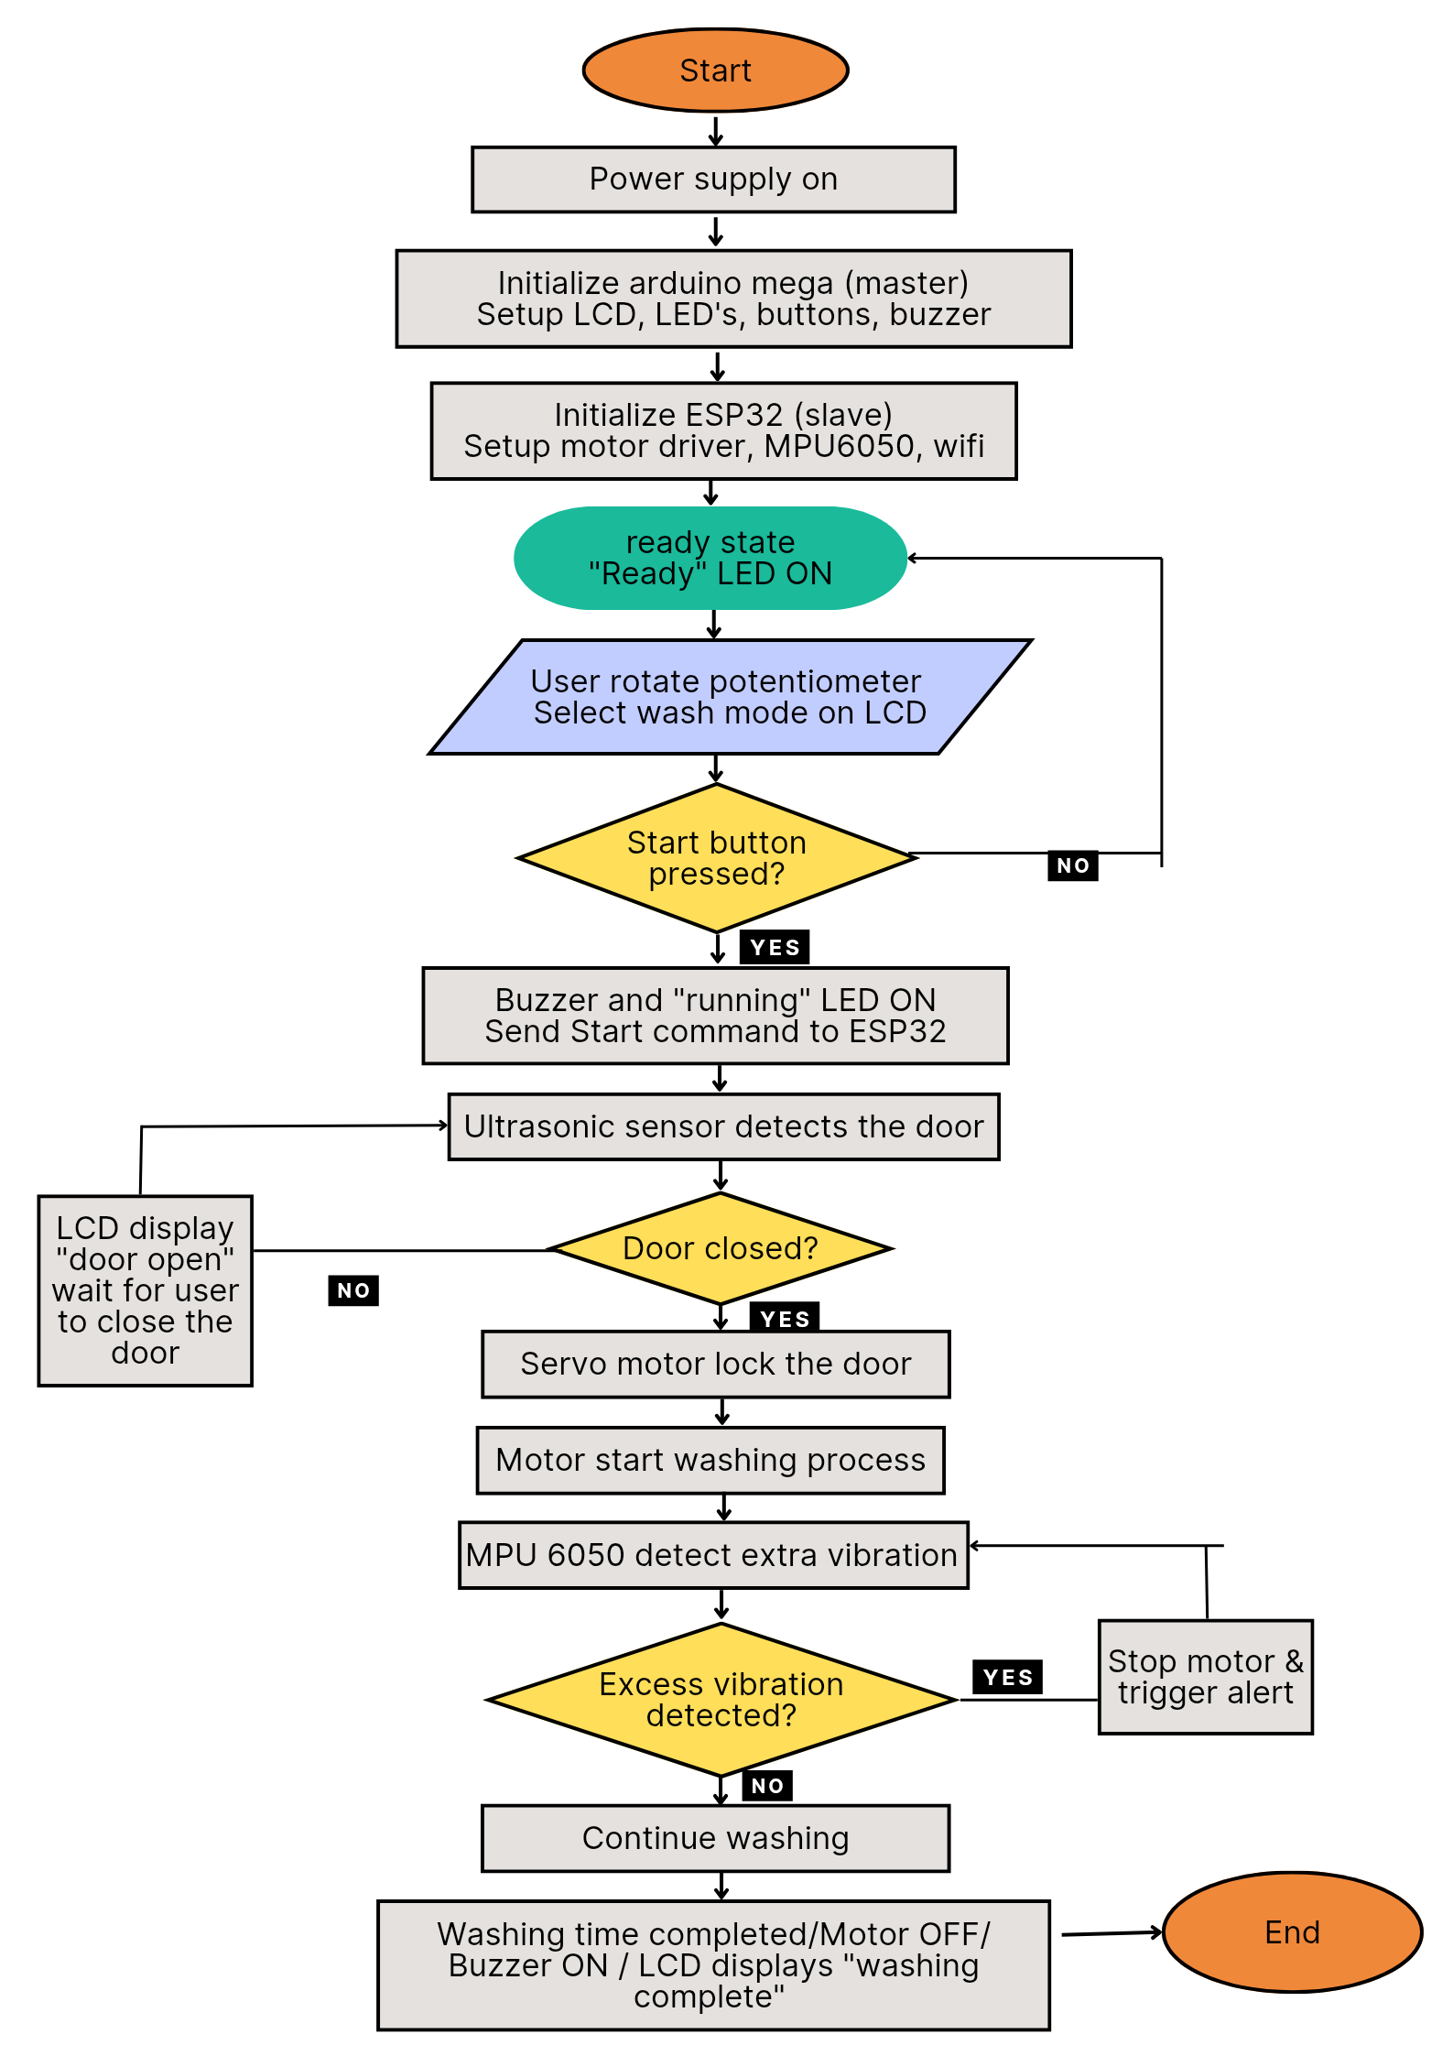
Figure 1. Flowchart

2.2 Schematic Diagram and Prototype Setup
The electrical design utilizes a distributed Master-Slave architecture to separate user interface tasks from high-power actuation. The Arduino Mega 2560 serves as the Master controller, directly managing the control panel components including the potentiometer for mode selection, the LCD display, status LEDs, and push buttons.
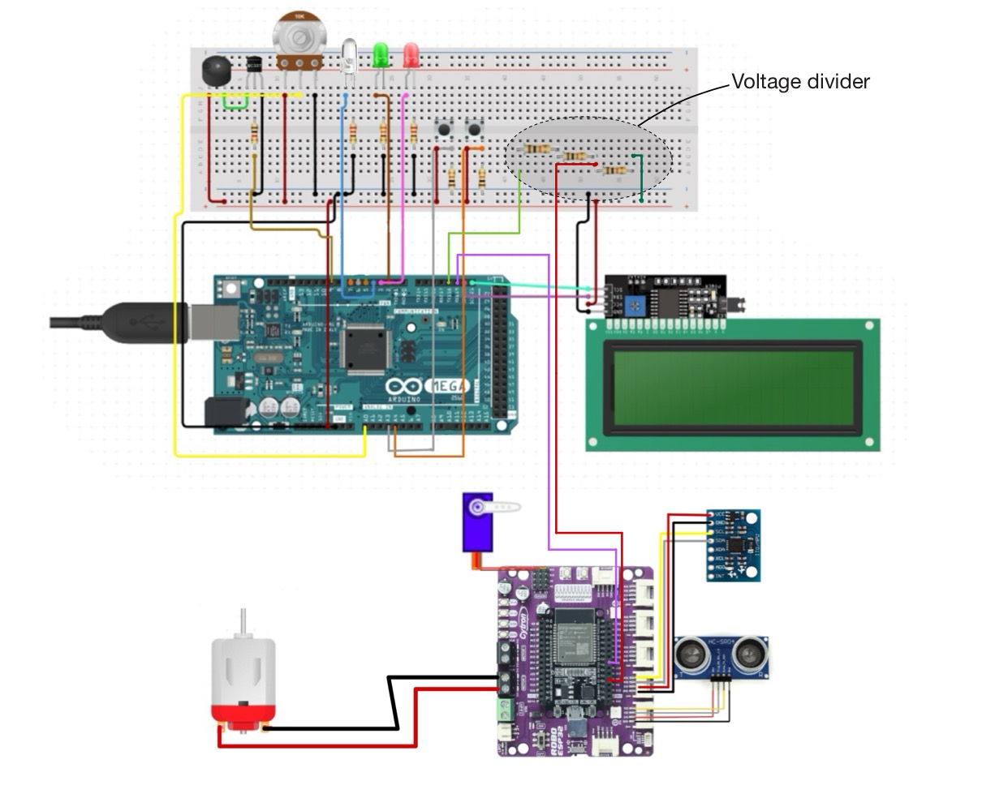
The ESP32 functions as the Slave controller, responsible for the hardware execution. It interfaces directly with the MPU6050 accelerometer to monitor vibration stability and an Ultrasonic Sensor to verify door closure safety. The DC motor, which drives the drum, is controlled by the ESP32 via a driver circuit to allow for varying PWM speeds according to the selected mode. The two controllers communicate via UART serial, while the ESP32 utilizes its Wi-Fi capability to bridge the system with the Blynk mobile application, enabling remote monitoring and real-time alerts.

Figure 2. Wiring diagram

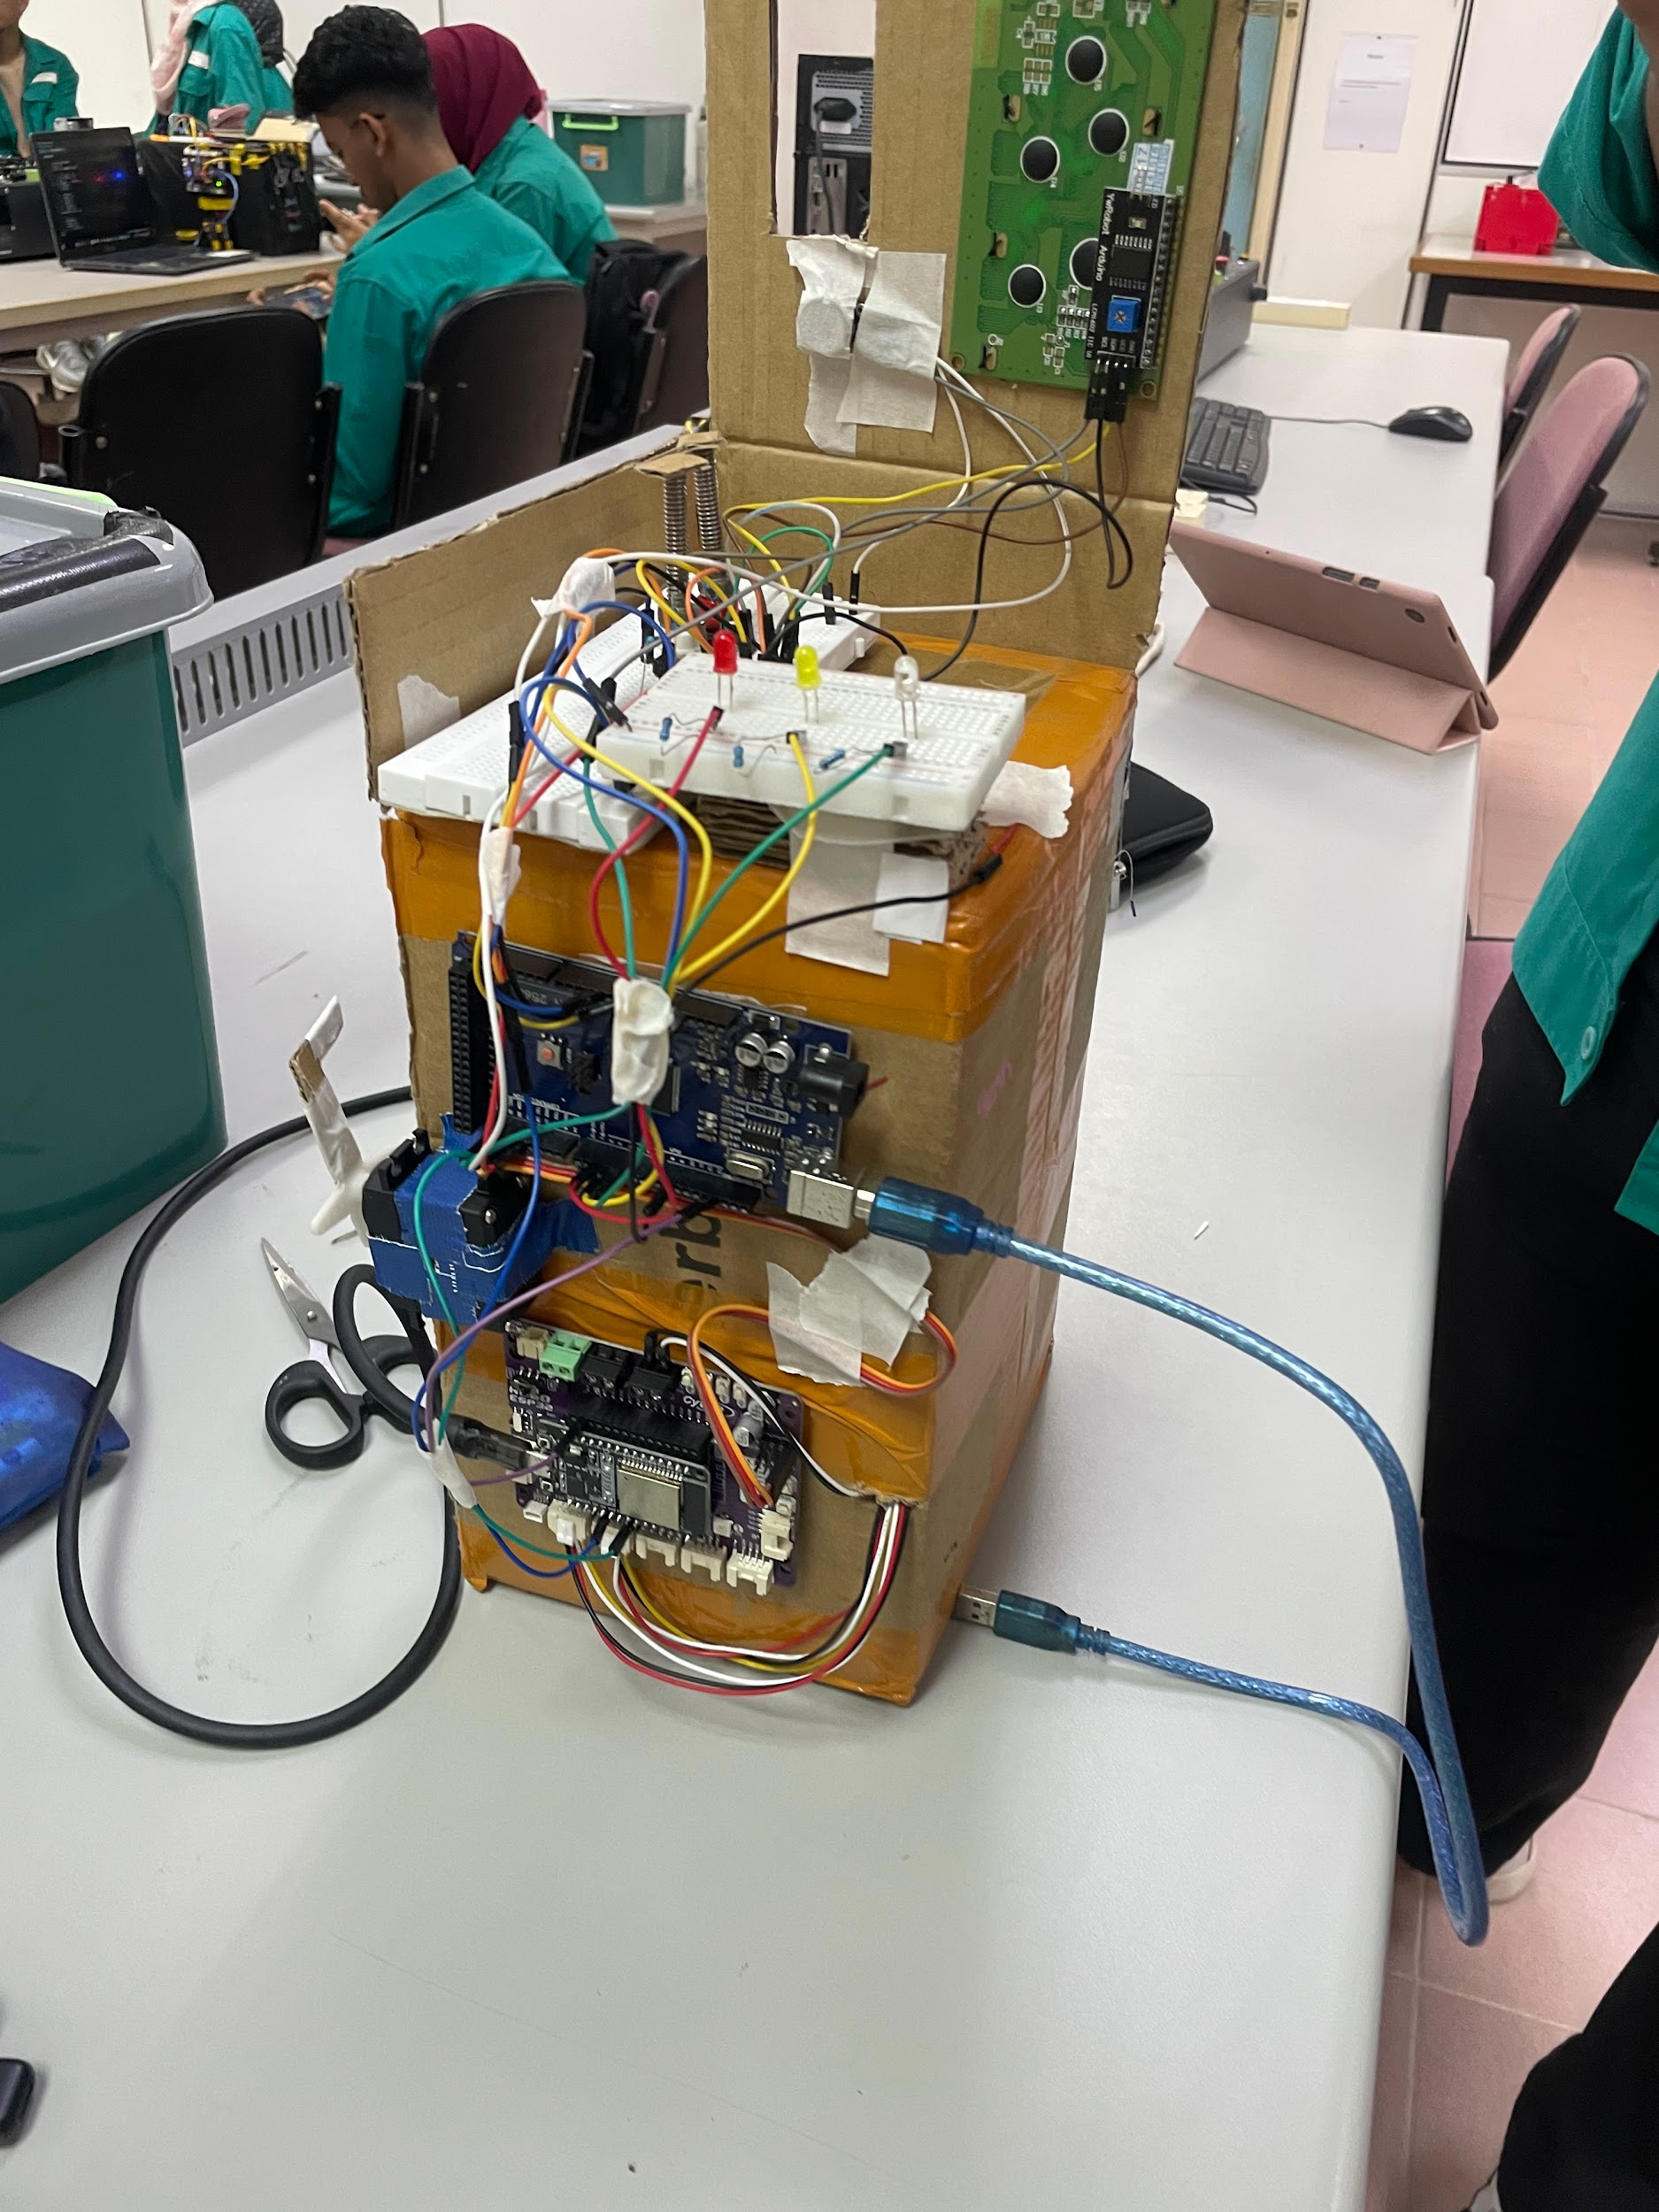
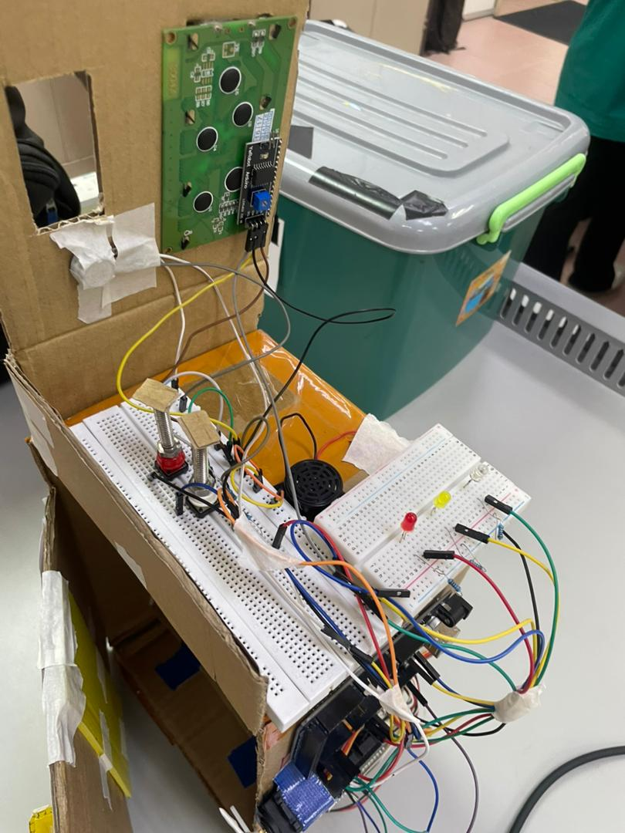

2.3 Equipment and Component List
Microcontrollers
- Arduino Mega 2560: Master controller for Human-Machine Interface (HMI).
- RoboESP32: Slave controller with built-in DC motor driver and Grove ports.
Sensors (Input)
- MPU6050 Module: 3-Axis Accelerometer and Gyroscope for vibration monitoring.
- HC-SR04 Ultrasonic Sensor: Distance sensor for door closure detection.
- Potentiometer (10kΩ): Analog rotary dial for Wash Mode selection.
- Push Buttons (x2): Tactile switches for Start and Stop/Reset commands.
Actuators (Output)
- DC Motor: Simulates the washing drum (driven via RoboESP32 internal driver).
- SG90 Micro Servo: Simulates the automatic door lock mechanism.
- Liquid Crystal Display (LCD) 2004: 20x4 character display with I2C backpack.
- Piezo Buzzer: For audio feedback and alarms.
- LEDs (x3): 5mm LEDs (white, Yellow, Red) for visual status indication.
Power and Connectivity
- USB Cables: Type-B (Mega) and Micro-USB (ESP32) for programming.
- Jumper Wires: Male-to-Male and Male-to-Female for circuit connections.
- Breadboard: For prototyping common connections (Ground/VCC).

3. RESULT AND DISCUSSION
3.1 System 1 Analysis (User Interface & Communication)
The initial phase of development focused on the responsiveness of the manual control interface and the reliability of the serial link between the Arduino Mega and the ESP32. The Arduino Mega was tasked with sampling the potentiometer's analog signal; testing confirmed that the firmware correctly mapped the 0–1023 range into four discrete operational modes: A, B, C, and D. As shown in Figure 3, the LCD successfully updated the status and mode selection in real-time as the potentiometer was rotated. Upon pressing the "Start" button (Figure 4), the system displayed high temporal efficiency, transitioning the LCD status from "MENU" to "RUNNING" immediately.
A critical component of this analysis was the latency of the serial communication protocol. Commands transmitted from the Mega specifically the 'r' (Run) and 's' (Stop) signals were monitored via a logic analyzer. The ESP32 consistently received and processed these commands within a latency window of <100 ms, ensuring that the motor actuation and IoT status updates remained synchronized with the user's manual inputs.
Furthermore, the ultrasonic sensor was validated as a safety interlock. By calculating the distance between the sensor and the door panel, the system successfully identified "Open" vs. "Closed" states. If the door was detected as open, the Arduino Mega successfully inhibited the "Start" command and generated an error message on the LCD, demonstrating robust hardware-level safety logic.
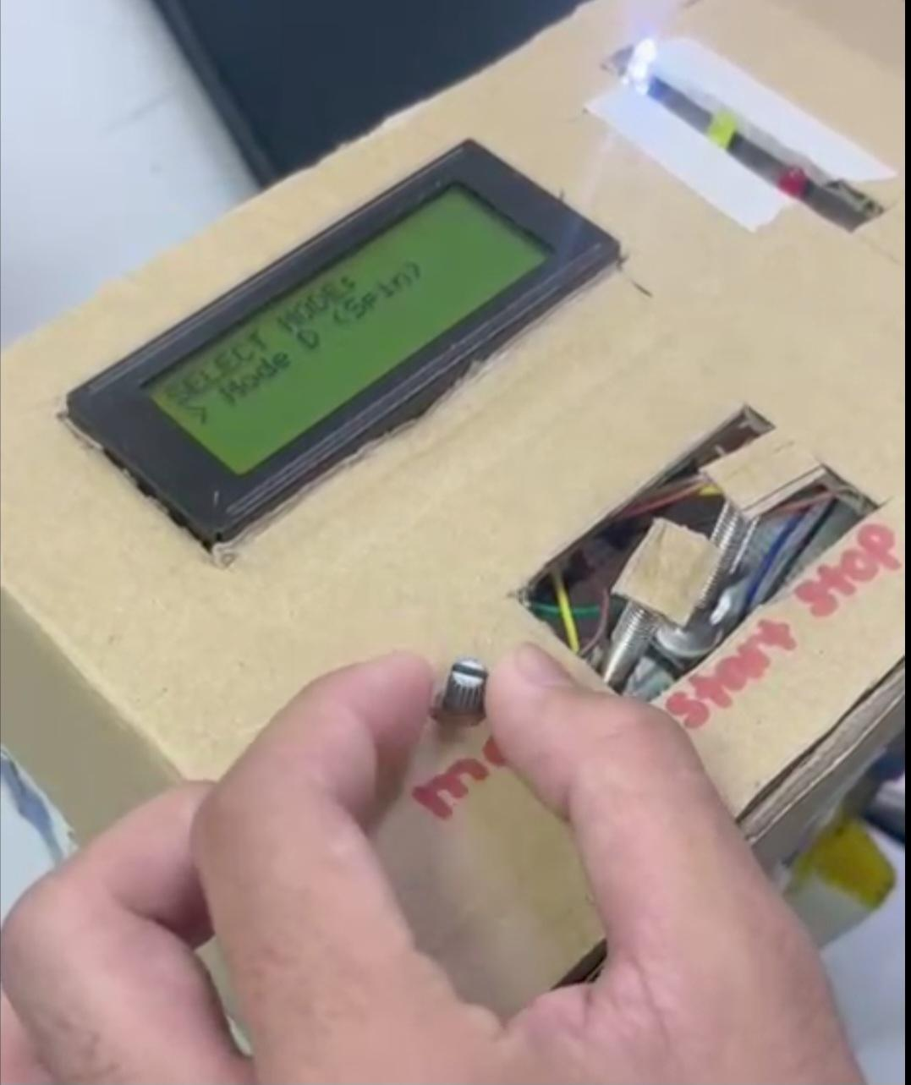
Figure 3
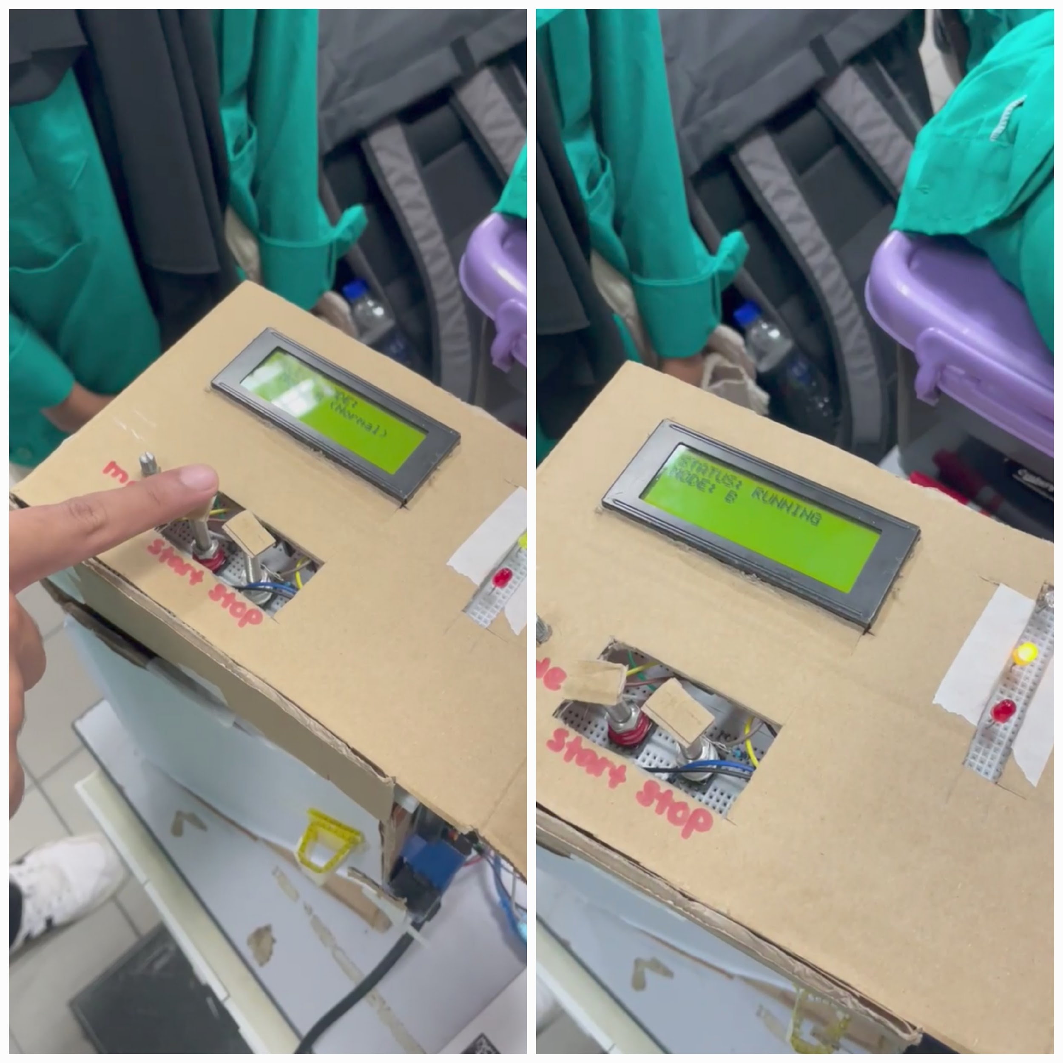
Figure 4
Action | Expected system output | Actual system output | result
Potentiometer rotation | Incremental Mode Selection (A-D) | Mode Change (A-D) Updated on LCD | success
Start button pressed | Logic 'r' sent to ESP32; System Run | System Transition to "RUNNING" | success
Door open (ultrasonic) | Operational Inhibit; Error Message | Motor Halt / "Door Open" Alert | success
Stop button pressed | Logic 's' sent to ESP32; System Halt | Immediate Motor Cut-off | success
Table 1: User Interface Response

3.2 System 2 Analysis (Motor Control & IoT)
This phase of the analysis evaluated the ESP32’s ability to execute variable load demands through Pulse Width Modulation (PWM) and its synchronization with the Blynk IoT cloud platform. The motor driver functionality was tested across the four pre-defined wash cycles to ensure linear speed scaling. As part of the actuation logic, the ESP32 successfully translated software-defined modes into distinct voltage outputs. For instance, Mode A (Gentle) was calibrated at a PWM value of 120 to provide a low-torque wash, while Mode D (Spin) utilized the maximum duty cycle (PWM 255) to achieve peak centrifugal force for drying.
A key achievement in this development was the bidirectional communication between the physical hardware and the Blynk mobile application. Testing confirmed that toggling the virtual switch within the app successfully overrode the Arduino Mega’s manual controls, reflecting the project’s goal of providing a "dual-control" safety architecture. When a remote "Stop" command was initiated via the app, the ESP32 immediately terminated the PWM signal to the motor and sent a serial interrupt to the Arduino Mega to update the physical "Ready" and "In-Action" LED indicators.
To further enhance system reliability, the IoT integration was tested for data consistency. The ESP32 pushed real-time status updates to the mobile interface, ensuring that the user was notified of the current mode and any safety triggers (such as door-open or vibration errors) with minimal latency. This integration demonstrates a robust "Smart" framework where manual operation and remote monitoring function as a single, cohesive unit.
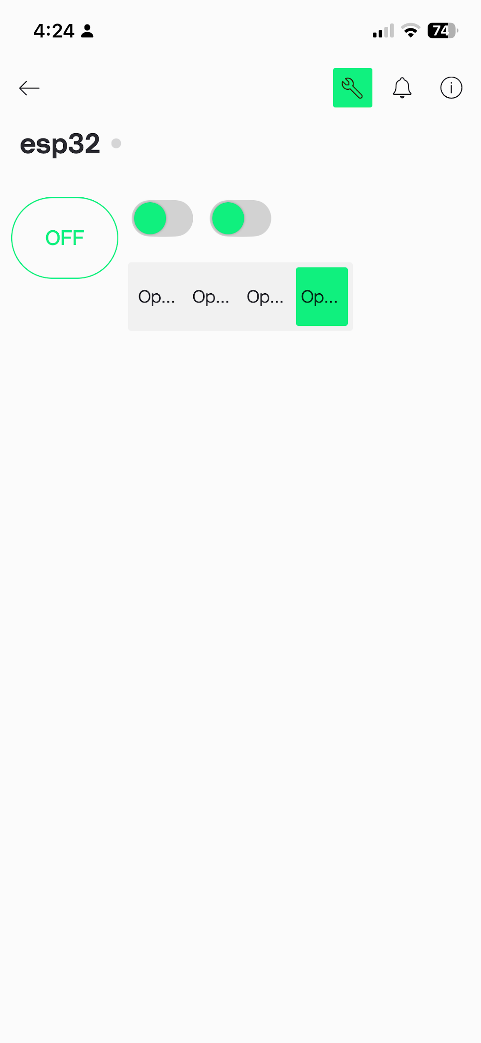
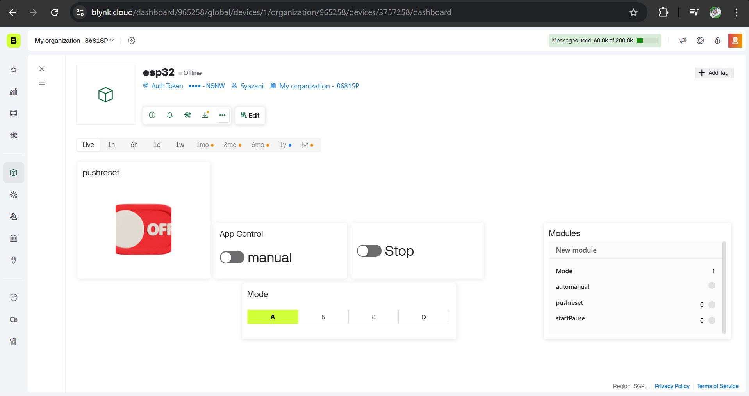

Figure 5
parameter | mode/action | PWM value | observation | result
Speed control | Mode A (Gentle) | 120 | Consistent slow-speed rotation | success
Speed control | Mode D(spin) | 255 | Maximum RPM achieved | success
IoT override | Blynk app toggle | N/A | Manual controls bypassed; LEDs updated | success
Safety halt | Remote stop | 0 | Immediate motor cessation | success
Table 2
3.3 Safety Sensor Analysis (Door & Vibration)
The final phase of testing evaluated the system’s ability to handle hazardous operational conditions through the integration of the HC-SR04 Ultrasonic sensor and the MPU6050 Accelerometer. These sensors function as a hardware-level safety interlock, ensuring that the machine remains in a safe state regardless of user input or remote commands.

Door Proximity Logic
- The HC-SR04 ultrasonic sensor was calibrated to monitor the physical state of the washing machine door. Testing confirmed a high degree of reliability in preventing motor activation when the door was detected as open. A safety threshold of 15 cm was established; any distance reading exceeding this value resulted in an immediate software inhibition. This prevented the DC motor from engaging and ensured that the system remained in a "Wait" state until the door proximity returned to within the safe operational range.

Vibration and Stability Monitoring
- To simulate mechanical failure or an unbalanced load, the prototype was subjected to manual agitation to test the MPU6050’s responsiveness. The system calculated the total resultant acceleration to determine stability. It was observed that once the vibration exceeded a threshold of 15.0 G (Total Acceleration), the ESP32 executed an emergency interrupt. This triggered a three-part safety response:
- An immediate power cut to the DC motor.
- The activation of the "DANGER" alarm on the LCD.
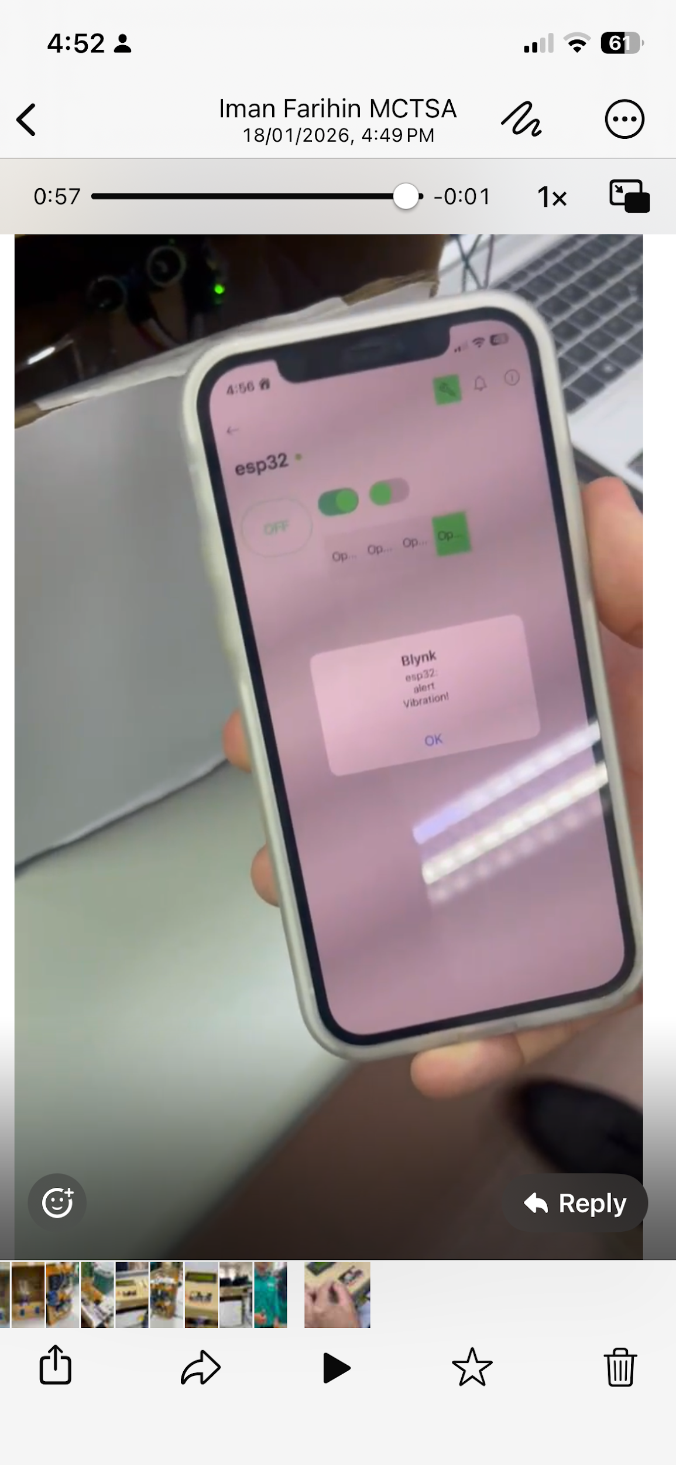
- A notification alert sent to the Blynk mobile application
Figure 6
4. CONCLUSION
The development of this Smart Washing Machine prototype successfully demonstrates the efficacy of a decentralized mechatronic architecture. By delegating tasks between an Arduino Mega for user interface management and an ESP32 for high-speed actuation and IoT connectivity, the system achieved robust performance with negligible processing latency. This separation of concerns ensured that the manual control interface remained highly responsive even during high-load motor operations and real-time sensor polling.
The integration of the MPU6050 accelerometer and HC-SR04 ultrasonic sensor provided a sophisticated safety framework, enabling the system to react autonomously to mechanical instability and door-status hazards. Furthermore, the implementation of the Blynk IoT platform successfully bridged the gap between traditional domestic hardware and modern mobile monitoring, allowing for secure remote overrides and real-time status updates. Ultimately, this project highlights how cost-effective embedded systems can be utilized to enhance the safety, reliability, and user experience of modern domestic appliances. Future iterations could further expand this framework by incorporating load-sensing algorithms or energy-consumption monitoring to provide even deeper insights into machine performance.

ACKNOWLEDGEMENT
The authors would like to thank the IIUM Mechatronics Department for providing the RoboESP32 and laboratory resources.
Conflict of interest
Authors contribution
References
- Arduino. (2023). Arduino Mega 2560 Rev3 datasheet.
https://www.arduino.cc/en/Main/ArduinoBoardMega2560
- Espressif Systems. (2023). ESP32 series datasheet.
https://www.espressif.com/en/products/socs/esp32
- Blynk Inc. (2023). Blynk IoT platform documentation.
https://docs.blynk.io
- Al-Fuqaha, A., Guizani, M., Mohammadi, M., Aledhari, M., & Ayyash, M. (2015). Internet of Things: A survey on enabling technologies, protocols, and applications. IEEE Communications Surveys & Tutorials, 17(4), 2347–2376. https://doi.org/10.1109/COMST.2015.2444095
- Gubbi, J., Buyya, R., Marusic, S., & Palaniswami, M. (2013). Internet of Things (IoT): A vision, architectural elements, and future directions. Future Generation Computer Systems, 29(7), 1645–1660. https://doi.org/10.1016/j.future.2013.01.010
- Yadav, A., & Kumar, R. (2018). Design and implementation of automatic washing machine controller using embedded system. International Journal of Engineering Research & Technology, 7(5), 1–5.
- Lee, E. A. (2015). The past, present and future of cyber-physical systems: A focus on models. Sensors, 15(3), 4837–4869. https://doi.org/10.3390/s150304837
- Patel, K. K., & Patel, S. M. (2016). Internet of Things-IoT: Definition, characteristics, architecture, enabling technologies, application & future challenges. International Journal of Engineering Science and Computing, 6(5), 6122–6131.
- Bolton, W. (2021). Mechatronics: Electronic control systems in mechanical and electrical engineering (7th ed.). Pearson Education.
- Rajput, S., & Pandey, S. (2019). IoT based smart home automation system using ESP32. International Journal of Scientific Research in Engineering and Management, 3(6), 1–6.

